**Product: Robinhood**

CONFIDENTIAL

Not for use in any form without the explicit written permission from Beningo Engineering.

|  |  |  |  |
| --- | --- | --- | --- |
| **Approval List** | | | |
| **Prepared by:** | Jacob Beningo | | **Date:** 01-28-2014 |
| **Approved by:** | Jacob Beningo | | **Date:** 01-28-2014 |
| **Approved by:** |  | | **Date:** |
| **Approved by:** |  | | **Date:** |
| **Approved by:** |  | | **Date:** |
| **Release Date:** | 01-28-2014 | **Current Release Version: 1.0** | See Revision History |

**REVISION HISTORY:**

|  |  |  |  |
| --- | --- | --- | --- |
| **Revision:** | **Description of Changes:** | **Date:** | **Revision By:** |
| 1.0 | Document Release | 01.28.2014 | JWB |
|  |  |  |  |
|  |  |  |  |
|  |  |  |  |
|  |  |  |  |
|  |  |  |  |
|  |  |  |  |
|  |  |  |  |
|  |  |  |  |

**REFERENCES:**

|  |  |  |
| --- | --- | --- |
| **Revision:** | **Document:** | **Author:** |
| 1.0 | Panda5AJ.1.5.1 Release Notes | Texas Instruments |
|  |  |  |
|  |  |  |
|  |  |  |
|  |  |  |
|  |  |  |
|  |  |  |
|  |  |  |
|  |  |  |

Table of Contents

1. Situation Appraisal 2

2. Objectives 3

3. USBBOOT 3

4. Fastboot 3

5. Adding Google Applications 3

6. Keeping the Display from Sleeping 4

7. Setting up SPAN 5

1. **Situation Appraisal**

Installing Android on the OMAP5 is a relatively straight forward process. There are a few limitations with the standard images that should be kept in mind such as the lack of support for google applications. There are also some customizations and shortcuts that can be taken in order speed up the development process.

1. **Objectives**

The objective of this document is to:

* Explain how install an Android image on the OMAP5
* How to add support for google applications
* How to configure the image for use with Robinhood

1. **USBBOOT**

There are a couple of different methods that can be used to update or completely update the onboard flash with a new image. For an Android system the most commonly used tool is usbboot. This is a tool that should have been compiled when the linux system was setup for android. This tool is used to cause the OMAP5 board to boot over USB. Once the board is booted other commands and scripts can be ran such as fastboot.

The usbboot utility can be ran from a terminal using the following:

sudo ./usbboot –f

The –f tells usbboot to start the device in a mode that supports the fastboot protocol for updating the flash file system on an Android device.

1. **Fastboot**

Fastboot is a protocol that is used to update the flash file system on the Android device. Once the device is booted in this mode the fastboot command can be used to update the image. There are two useful ways in which to update the system. The first is a complete update where the entire flash system is updated at one time. This will erase the entire flash system and load a new linux kernel and Android file system. In order to do this, the following command should be ran from the terminal:

sudo ./fastboot.sh

There may be times when there are updates to the linux kernel that need to be pushed to the device. Rather than wipe the entire system and be forced to reload any applications that may have been installed on Android, there is an option that can be used to update the Linux kernel only. The command executed in the kernel would look like the following:

sudo ./fastboot flash zImage kernel

In this instance, fastboot will flash the zImage partition with the local (updated) kernel file. The kernel file could have any number of names but for the example it is kept as kernel. Using this process once the system is setup will greatly speed up the time needed to flash the file system. It will also preserve the android file system so any applications or configurations performed on Android will not be blown away.

1. **Adding Google Applications**

It may be necessary to use google services or applications within the Android system. If the device is not an official device that is going to market and has Google sign-off then the device will not have google services. There are a couple of methods for going about including the google services. The first is to install them after the image has been flashed. This can be done using the following procedure:

1. Download the GAPPS from goo.im/gapps
2. Make sure you select the correct Android Version
3. Unzip the contents
4. Copy the system folder to the location of the adb utility
5. Open a terminal and issue the following commands
   1. Adb devices (check to make sure an android device is connected)
   2. Adb root (start adb in root mode)
   3. Adb remount
   4. Adb push system /system
6. In Android under settings you should see the google applications now listed
7. Restart the system
8. You should see that android is being upgraded
9. Follow-up the onscreen prompts to finish setup
10. Run google services and applications

If there are multiple devices that need to be setup this can become a time consuming and annoying procedure. The google services can be added to the images RAMDISK by using the following procedure.

1. Download the GAPPS from goo.im/gapps
2. Make sure you select the correct Android Version
3. Unzip the contents
4. Merge the system folder contents into Androids compiled output system folder. This is most likely located in mydroid/out/target/product/panda5/system/
5. Rebuild Android
6. Use the flashing procedure earlier in this document to update the system.
7. Restart the system
8. You should see that android is being upgraded
9. Follow-up the onscreen prompts to finish setup
10. Run google services and applications
11. **Keeping the Display from Sleeping**

The infotainment system is not going to want the displays to automatically go to sleep. This control should be done through the Android application. By default Android will have a 30 seconds timeout. This time can be changed but none of the available options is to never sleep.

The display can be setup to never sleep by using one of the developer mode options. Developer mode can be entered by clicking on the settings->About Tablet tab. Then continuously click on the build number until it shows “You are now a developer.

The developer options tab should appear above the “about tablet” tab. Click on it and check the “stay awake” checkbox as seen in the image below:

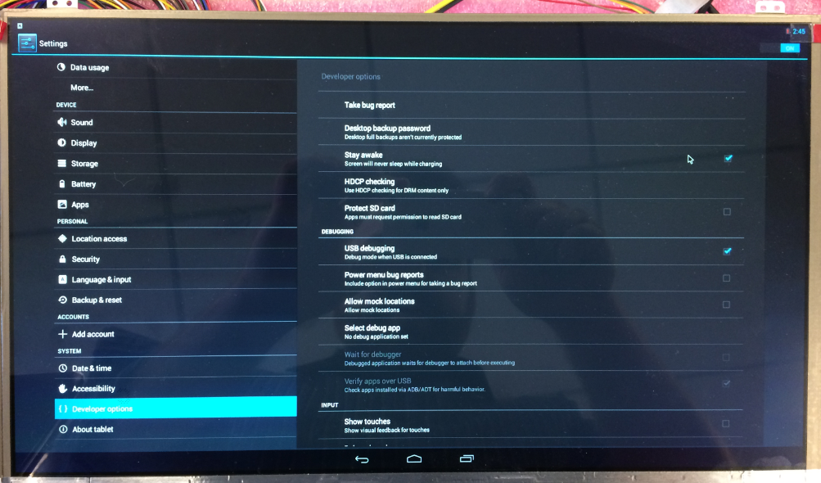

1. **Setting up SPAN**

In order to run the Robinhood application successfully on the Android platform it is necessary to setup the spanhost location. This can be done my copying a new hosts file to the kernel /etc/ folder. The hosts file will need an entry such as the following

192.168.1.14 spanhost

Where 192.168.1.14 is the location of the spanhost computer.

This file needs to be pushed to the kernel using root. The procedure can be found below:

1. Put the new hosts file in the same directory as adb.
2. Open a terminal and issue the following commands
   1. Adb devices (check to make sure an android device is connected)
   2. Adb root (start adb in root mode)
   3. Adb remount
   4. Adb push hosts /etc
3. It may be necessary to restart the operating system in order for the changes to take effect.

The system is now ready to have the Robinhood application installed.

1. **Installing Robinhood**

There are a number of ways to install the Robinhood application on Android. The first is to simply push the apk over adb. The second is through Eclipse.

If running the application through Eclipse right click on the Mai nActivity folder and select run as Android application. This will run the application without interference from the debugger. If the program is going to be debugged then right clicking and selecting debug as android device can be selected instead.